Dimensional Reduction Using PCA and Auto-encoders
Output:

Principal Component Analysis (PCA)
Figure 1:
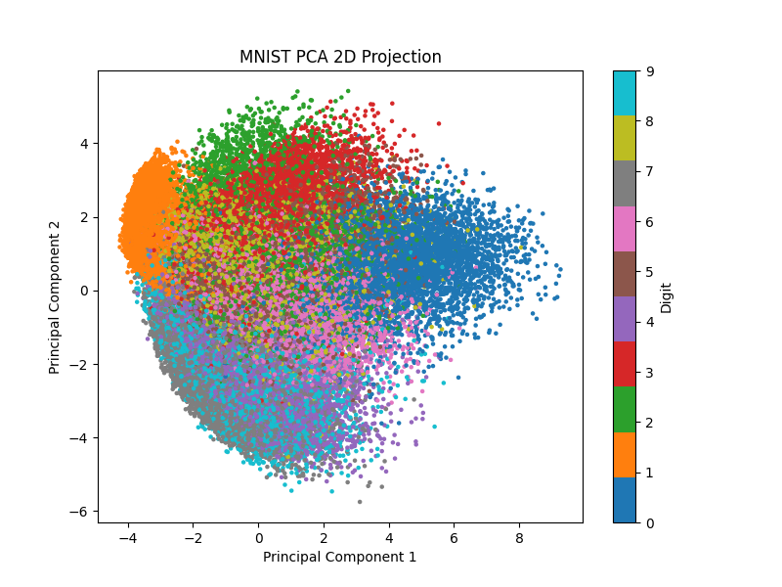

Basic Autoencoder
Figure 2:
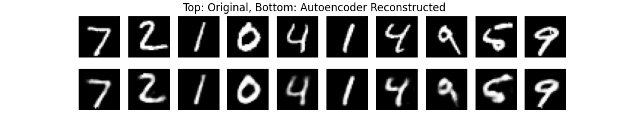

Latent Autoencoder (Visual Map)
Latent Space Visualization
Figure 3:
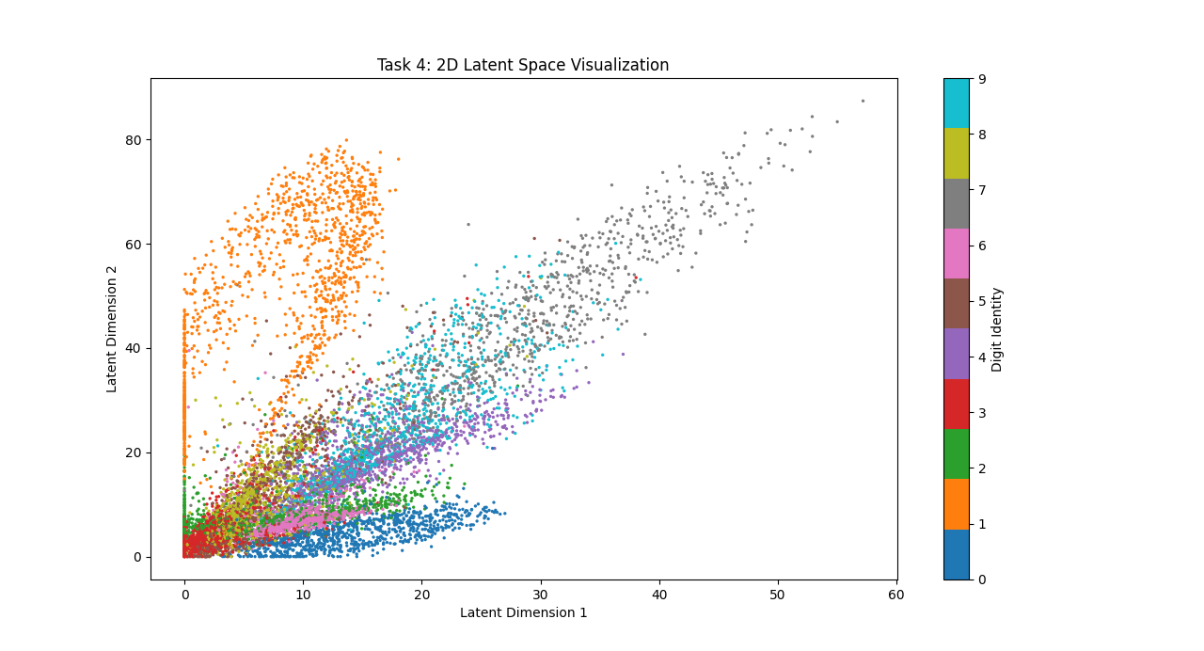

Generative Walk through Latent Space
Figure 4:
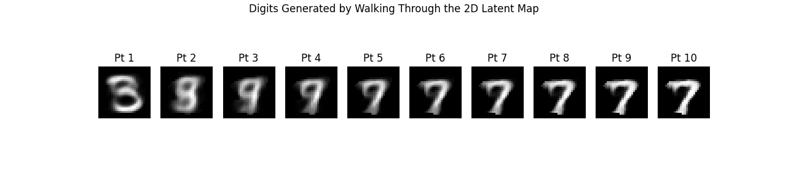

VQ-VAE Simulation
Figure 5:
